**Task 2**

* Consider that your want to start an open-source project in your organization. Perform all the standard operation to create a repository with minimal permision for all the users. It should contain.

1. Proper open source structure
2. Proper Readme
3. Add 2 collaborator
4. Host GitHub Pages using settings (Designed to host your personal, organization, or project pages from a GitHub repository)
5. Create a Github account.
6. In the upper-right corner of any page, use the drop-down menu, and select New repository.

A repository is like a place or a container where something is stored; in this case we're creating a Git repository to store code. To create a new repository, select **New Repository** from the + sign dropdown menu.

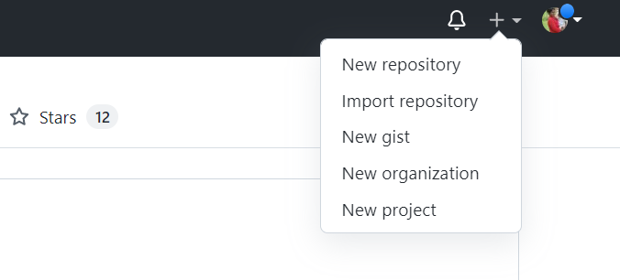

1. Enter a name for your repository (e.g, "Demo") and click **Create Repository**. Don't worry about changing any other options on this page.

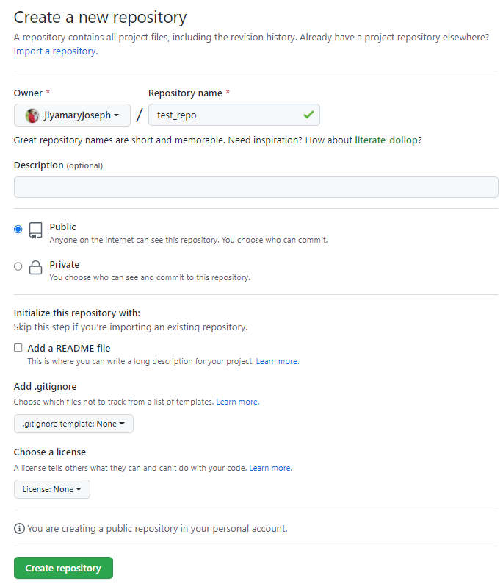

1. Once create the repository ,it will be look like below.

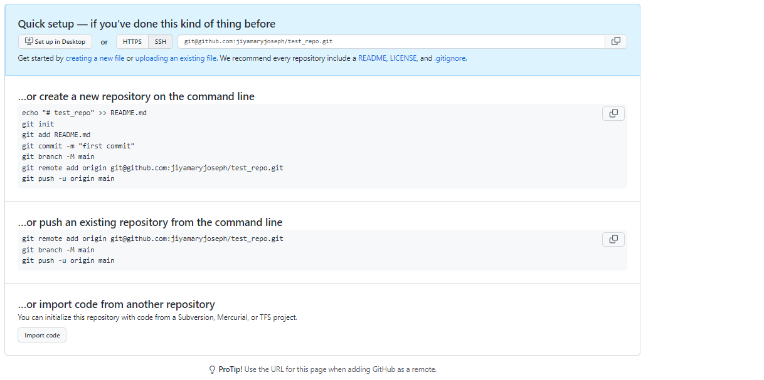

1. Initialize this repository with a README.

Create a README.md file in visual studio code and using terminal initialize the folder and commit and push the file using command.

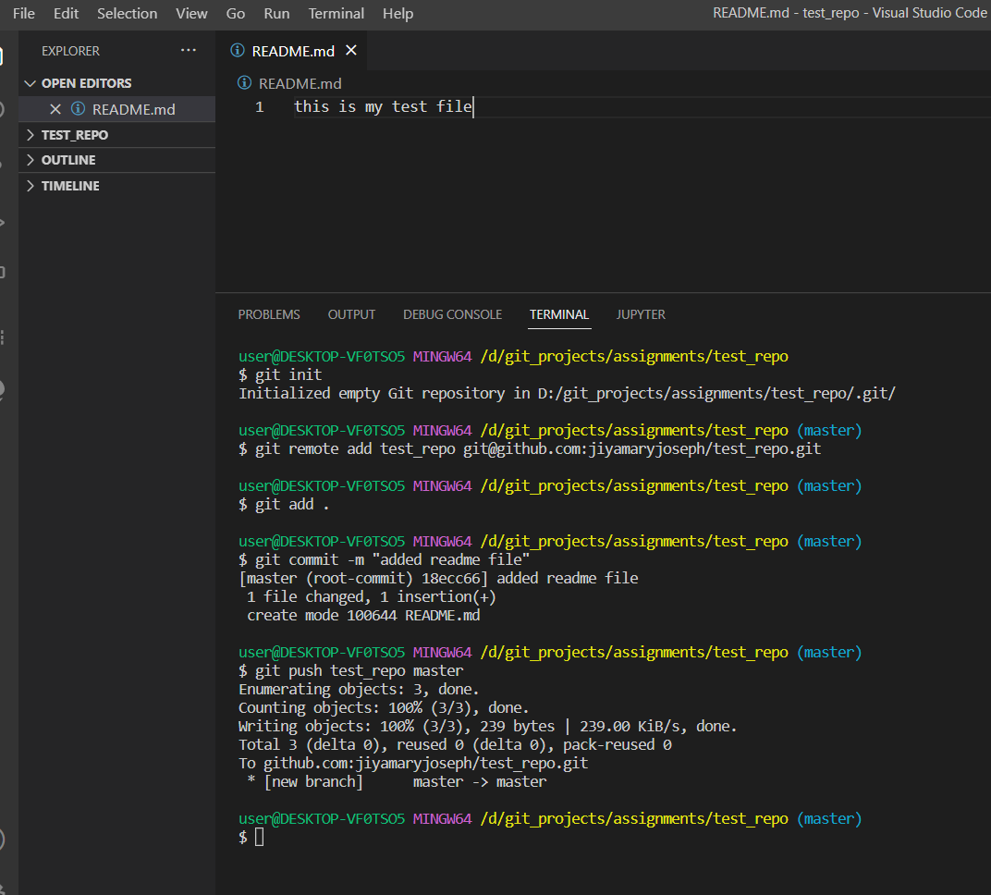

1. The repository has set up.HURRAY.. Refresh the page you can see as below.

